**Task 1: Documentation of current test Katalon scripts: Due date ~Fri, 12 Feb**

**Overview of Katalon Studio:**

Katalon Studio is simple and easy to use, even for users without much programming and scripting experience. If you are new to Katalon Studio but have some basic Java and/or Groovy skills and a brief understanding of testing, then you should have no problem making use of this tool.

Here are some initial thoughts on the documentation outline:

1. How to guide to use current Katalon scripts for a GRiD testing cycle

* how to get set up (101 for a new person)
  + Steps to setup katalon Studio on Windows Machine
    - Go to Katalon Studio official website – [Katalon Studio](https://www.katalon.com/)
    - Click on “Start for Free”, you will have to create an account. Follow the steps on the page.
    - After the account has been created, click on “Download Now”
    - You will download Katalon Studio for any operating system you are using.
    - After the download is complete, The file will be downloaded as a zip file in your Download folder. Double click on the zip file to unzip. After the unzip is completed, open the unzip folder. After you open the folder, double click on the Katalon.exe.
    - In order to activate the tool, it will ask for the email Id and password. Enter the credentials used while creating account on Katalon
* where to get the scripts?
  + The importance of having automation testing scripts is to save time on testing same thing manually. The purpose of the automation script is you create it once and run many times. We have created scripts for various things (FG3D, GRiD Homepage, Legacy Exports, etc.) these scripts have many different parameters and automation script will test all the parameters one-by-one. So, by running these scripts will save time for the testers deployment time. This also gives a detailed report of all the test cases of pass or fail.
    - The katalon Scripts are placed in GitHub.
    - GitHub Link: <https://github.com/CRREL/KatalonTesting>
    - You will need to clone the project in your local workstation.
    - Cloning a project using command line:
      * On GitHub, navigate to the main page of the repository.
      * Above the list of files, click Code.

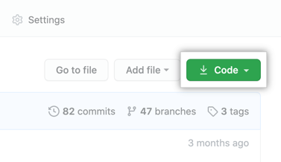

* + - To clone the repository using HTTPS, under "Clone with HTTPS", click the clipboard
    - Open a command line in your workstation.
      * The window, which is usually called the commandline or command-line interface, is a text-based application for viewing, handling, and manipulating files on your computer. Other names for the command line are: *cmd*, *CLI*, *prompt*, *console* or *terminal*
    - Change the current directory to the location where you want the cloned directory.
      * Once you open a command line, it usually starts at your home directory. From there you want to go to download folder. You can run following command to go in your Download folder.
        1. cd Download (same for MAC and Windows)
    - Before you use git from command line you will need to download git
      * To download Git for widows click on GitHub
    - Type git clone, and paste the URL you copied earlier.
      * git clone https://github.com/CRREL/KatalonTesting.git
    - Press ENTER
      * $ git clone https://github.com/CRREL/KatalonTesting.git
      * > Cloning into `Spoon-Knife`...
      * > remote: Counting objects: 10, done.
      * > remote: Compressing objects: 100% (8/8), done.
      * > remove: Total 10 (delta 1), reused 10 (delta 1)
      * > Unpacking objects: 100% (10/10), done.
* The structure of the Katalon Project
  + After you have katalon Studio open, click on File and “Open Project”
  + Open the Katalon Project folder “KatalonTesting” you cloned earlier from GitHub.
  + After you open the project, the structure should look like following:
  + “Test Cases” tab is where all the test cases are created and those can be executed individually.
  + “Object Repository” tab is where all the page elements (Attributes, xpath, url, etc) are created.
  + “Test Suites” tab is where we combined all the test cases and run them at once. Instead of running the test cases individually, it’s easier to run them simultaneously.
  + “Data Files” tab is where are data is sitting. So each test cases have different parameters and instead of hard coding them to the script we have created a Data File where it read from.
  + “Test Listener” tab is where we have BeforeTestSuite and AfterTestSuite methods are created. So before you execute the test suite, it will run the BeforeTestSuite method. That method will open the browser and login to the page.

* how to run the scripts
  + - Now you know are familiar with the project structure, here are the steps to run the script.
    - For this example we will run “GRiD FG3D” test suite.
    - Double click on the GRiD FG3D” test suite.
    - You should see 3 test cases in that “GRiD FG3D” test suite.
    - Graphical user interface, text

      Description automatically generatedOn the right of the page, you will see “Run” and check marks. Make sure all of them are checked. We need to check them because so all of them can be run one by one automatically.

* + - In order to run this script, op top of the page you will see a play button next to a bug button. A screenshot of a computer

      Description automatically generated with medium confidence
    - This will now execute the test suite and it will run all the test cases one by one. The time of the execution depends on the amount of the test cases are mentioned in the test suite.
* how to interpret errors

1. how to modify or create new scripts for a GRiD testing cycle?
   1. We need to install Katalon Automation Recorder extension for Google Chrome.
      1. Click [here](https://chrome.google.com/webstore/detail/katalon-utility/ljdobmomdgdljniojadhoplhkpialdid) to install the Katalon Automation Recorder extension for Chrome
      2. You should see a Katalon Recorder symbol on top left of the chrome window.
         1. Graphical user interface

            Description automatically generated



* 1. Creating script from Katalon Recorder. For training purpose we will test a GRiD login
     1. Launch Katalon Studio and click **New > Test Case** on the main toolbar. Provide a name for your test case and click **OK**. An empty test case will be created.

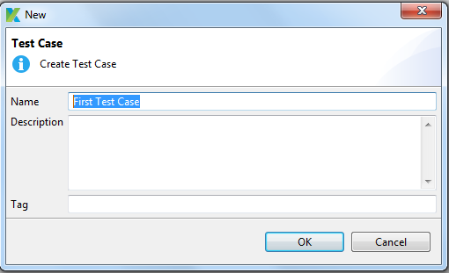

* + 1. Click **Record Web** from the main toolbar.

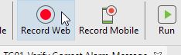

* + 1. The **Record** dialog will be displayed. Change the starting URL to <https://grid.nga.mil/grid>.

* + 1. Select a browser Chrome, then click **Record** to start recording the test case.

* + 1. Once your application has been launched, click on the **Username / Password Login** button. When you hover over a text, it will have red border. You will be directed to the Login page.

* + 1. Enter your valid username and password then click **Login**.

* + 1. Once you are logged in to GRiD home page will appear.
    2. You can stop the recording anytime by clicking **Stop**

* + 1. When you are done recording, click **OK** or **Save Script** to save the recorded actions into Katalon Studio.

* + - 1. You will be prompted to save captured objects to the **Object Repository**, which can be reused whenever needed. You can also create a folder to maintain page objects in desired structure. Click **OK** to continue.

* + 1. Recorded objects and actions are saved in the test case as shown below.

* + - 1. Click **Run/Play** to execute recorded test cases in your desired browser.

* + 1. Blow is the Script Code for Record and Playback that was created in the background.

WebUI.*openBrowser*('')

WebUI.*navigateToUrl*('https://grid.nga.mil/grid/')

WebUI.*click*(*findTestObject*('Page_Home GRiD/a_Username Password Login'))

WebUI.*setText*(*findTestObject*('Page_Login GRiD/input_Username or Email_username'), 'bhavik1989')

WebUI.*setEncryptedText*(*findTestObject*('Page_Login GRiD/input_Password_password'), 'VfeyxFJmfCv3/zRO53wINNelzPCSDwzE')

WebUI.*click*(*findTestObject*('Page_Login GRiD/input_Password_btn btn-primary'))

WebUI.*click*(*findTestObject*('Object Repository/Page_Login GRiD/a_Login'))

WebUI.*closeBrowser*()

* + 1. Those are all the steps to create a script using Katalon Recorder and the simplest way.

1. Steps to Create API test scripts using Swagger.
   1. The Swagger specification defines a set of files required to describe such an API. These files can then be used by the Swagger-UI project to display the API and Swagger-Codegen to generate clients in various languages. Additional utilities can also take advantage of the resulting files, such as testing tools.
   2. In Tests Explorer, right-click on any folder within **Object Repository** to display the context menu and select **Import > From Swagger**.

* 1. After you click on “From Swagger”, you will get a following box where you need to path of the swagger file.

* 1. After you have successfully imported all Swagger file, you will get all the API calls under “Object Repository”, similar to image below.

* 1. Graphical user interface, website

     Description automatically generatedIn Order to run the API request, double click on one of the API Request and validate that the Authorization has the API token Key. This would-be location under “HTTP Header”
  2. After that has been validated, you can press Play button and it will run the API request and return response code 200.